**Are You Going to Eat That? A Composting Pilot Case Study**

An  Funded Project with:

|  |  |
| --- | --- |
| **Macintosh HD:Users:zoekaiser:Desktop:bcpgrgbl (1).jpg** | **Macintosh HD:Users:zoekaiser:Desktop:CFSD - Image - Johns Hopkins University Logo 2.ashx.gif** |
| **Macintosh HD:Users:zoekaiser:Desktop:logo_OfficeSustain.jpg** | **Macintosh HD:Users:zoekaiser:Desktop:Screen Shot 2012-07-30 at 8.39.00 PM.png** |
| **bcf logo fnl.jpg** | **Constellation-Exelon logo.jpg** |

**Schools:** Midtown Elementary, Curtis Bay Elementary/Middle, Federal Hill Preparatory, Calvin Rodwell Elementary/Middle, Baltimore Montessori School Elementary/Middle School

**Project Team:** Abby Cocke from the Baltimore Office of Sustainability, Keith Losoya and Patrick Richter from Waste Neutral, Zoe Kaiser (Intern) from Johns Hopkins University

**Table of Contents:**

**Introduction……………………………………………………….Page 3**

**Process……………………………………………………………….Page 3**

**Obstacles…………………………………………………………….Page 5**

**Results………………………………………………………………..Page 7**

**Commentary and Reflection……………………………….Page 12**

**Engagement and Support……………………………………Page 13**

**Funding Resources……………………………………………..Page 13**

**Exhibits………………………………………………………………Page 14**

**(A) Composting Pilot “HOW TO” Sheet.**

**(B) Solid Waste Volume Log Sheet**

**Introduction**

In the fall of 2011, the Baltimore Office of Sustainability coordinated an initiative to pilot a food waste recycling (composting) program in select elementary and middle schools in the Baltimore City Public School system (BCPS). While initially eight schools were selected, only five schools (Midtown Academy, Curtis Bay Elementary/Middle School, Federal Hill Preparatory, Calvin Rodwell and Baltimore Montessori School) fully participated in the pilot, and produced positive results. The food waste hauler, Waste Neutral, worked with the schools to customize the separation and disposal process since the infrastructure and dining process varies between each school.

This coordinated implementation went smoothly in most schools where there was strong buy in and participation from the principals, teachers, parent volunteers, janitorial and support staff, and students. The pilot schools began separating their food waste as part of their daily routine and as a result of this pilot; **participating** **schools diverted 34,525 pounds of waste from landfills and incinerators** to be recycled into compost.

In the late spring and early summer compost made from the food waste collected was delivered to participating schools, community gardens and urban farms. This gesture had a positive educational impact on the participants as a tangible example of the “fruits of their labor”. After seeing the compost; students, parents and faculty expressed a new understanding and appreciation of this waste being a recyclable resource.

**Process (Measuring)**

The process began with a measure. One of the primary goals was to benchmark the current level of waste going into the pilot schools designated dumpsters to determine how much would be diverted when the separation of food waste was implemented. Each dumpster was watermarked and the staff or lead coordinator was given a sheet to mark the fill levels prior to pickup (See Exhibit B).

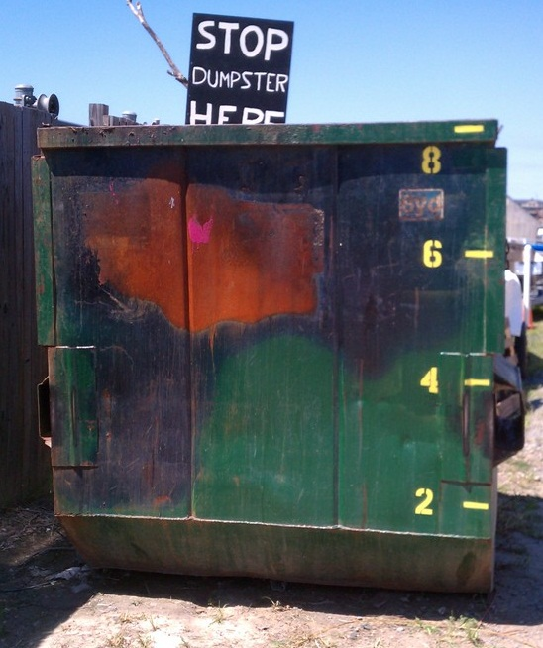

**Process (Implementation)**

Each school that participated in the composting process had a different set-up based on the infrastructure of the school. These logistical details were driven by the layout of the specific school, and which areas were used for meal times. The suggested composting set-up would be best performed in a school where breakfast and lunch were served in a centralized area and can utilize multiple waste disposal bins for liquids, recyclables (a container for food waste and another for paper, plastic, glass and metals) and solid waste. The area where the multiple bins were located was referred to as “separation stations”.

For each school, our team worked closely with one individual. That person assembled a “compost crew” comprised of students and other supporters who helped run the day-to-day operations. Many supervisors of the composting process spoke highly of students’ level of engagement; from interest in the “gross-er” parts of trash, to peering into the dumpster, to learning about the composting process itself.

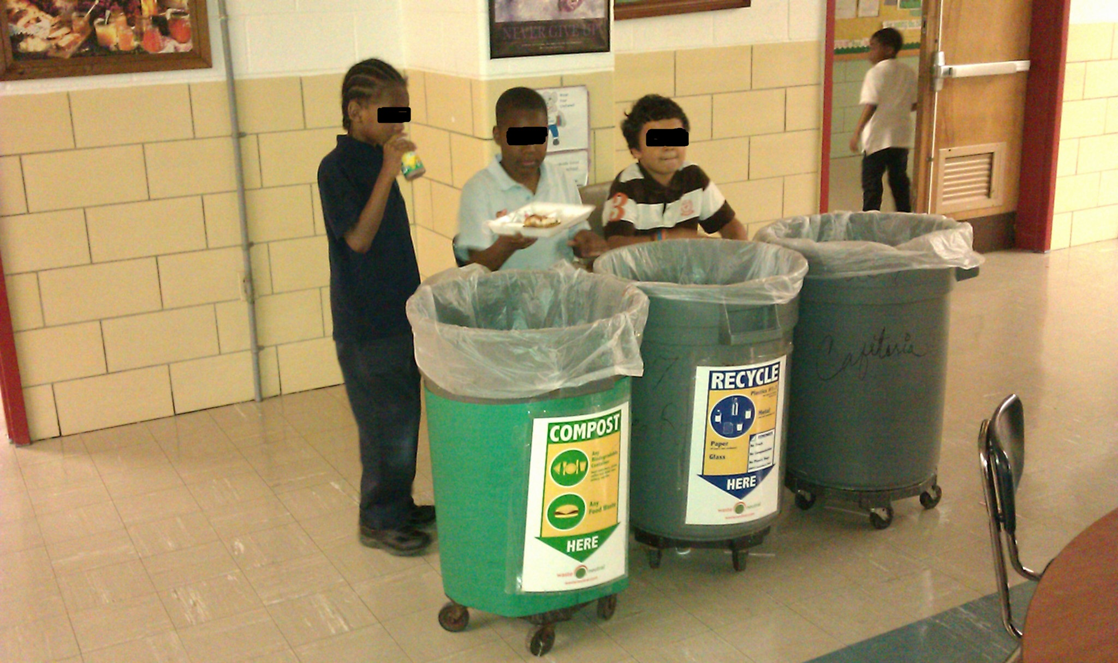

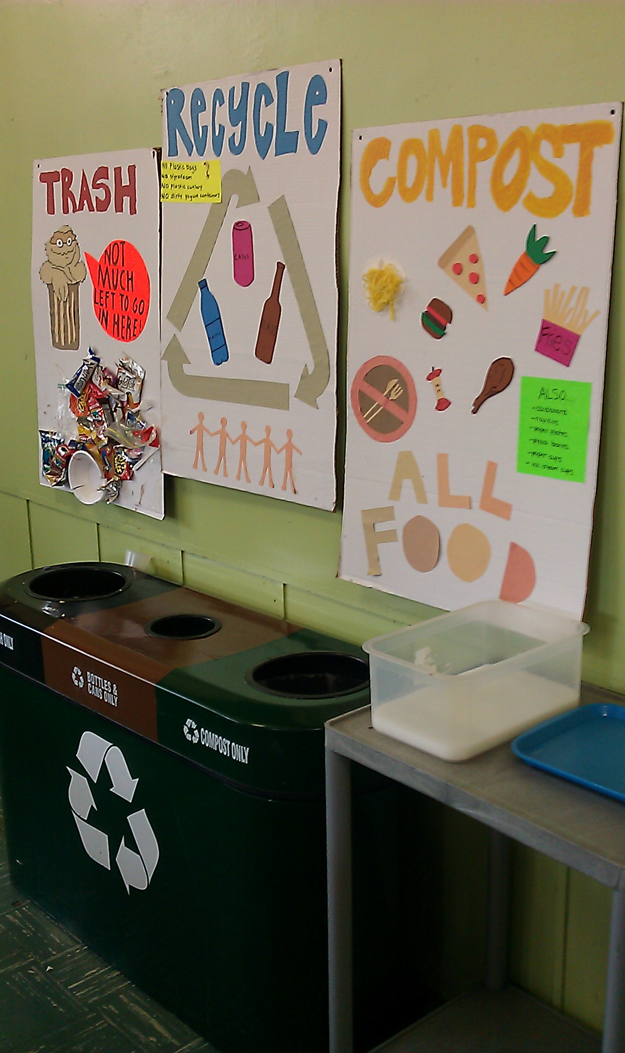

When we first started the program we immediately identified process issues where we observed that in most cases a large number of students would get up at the same time to dispose of their waste, causing a traffic jam at the separation stations. To remedy this we redesigned the signs and added a numerical order so that students could line up and dispose of waste in a more organized manner.

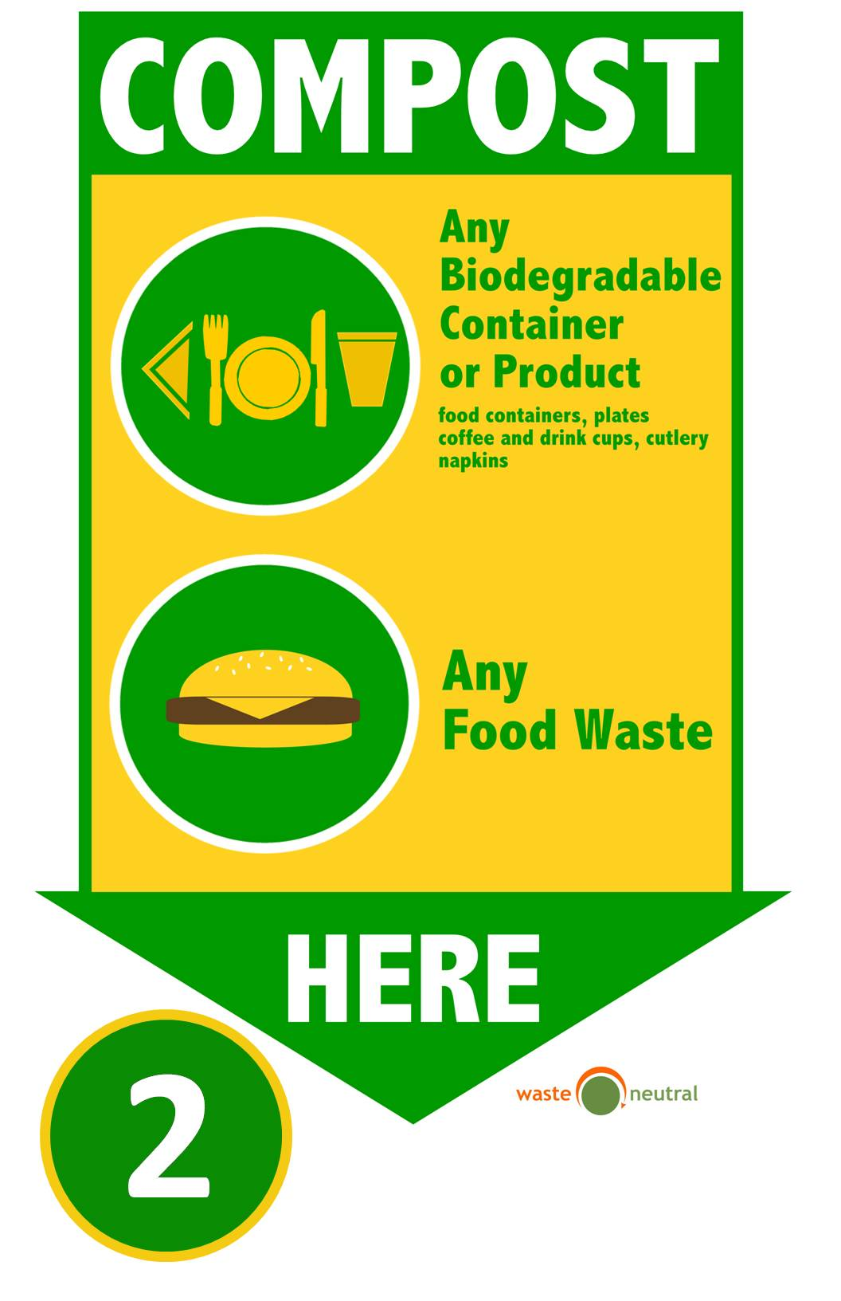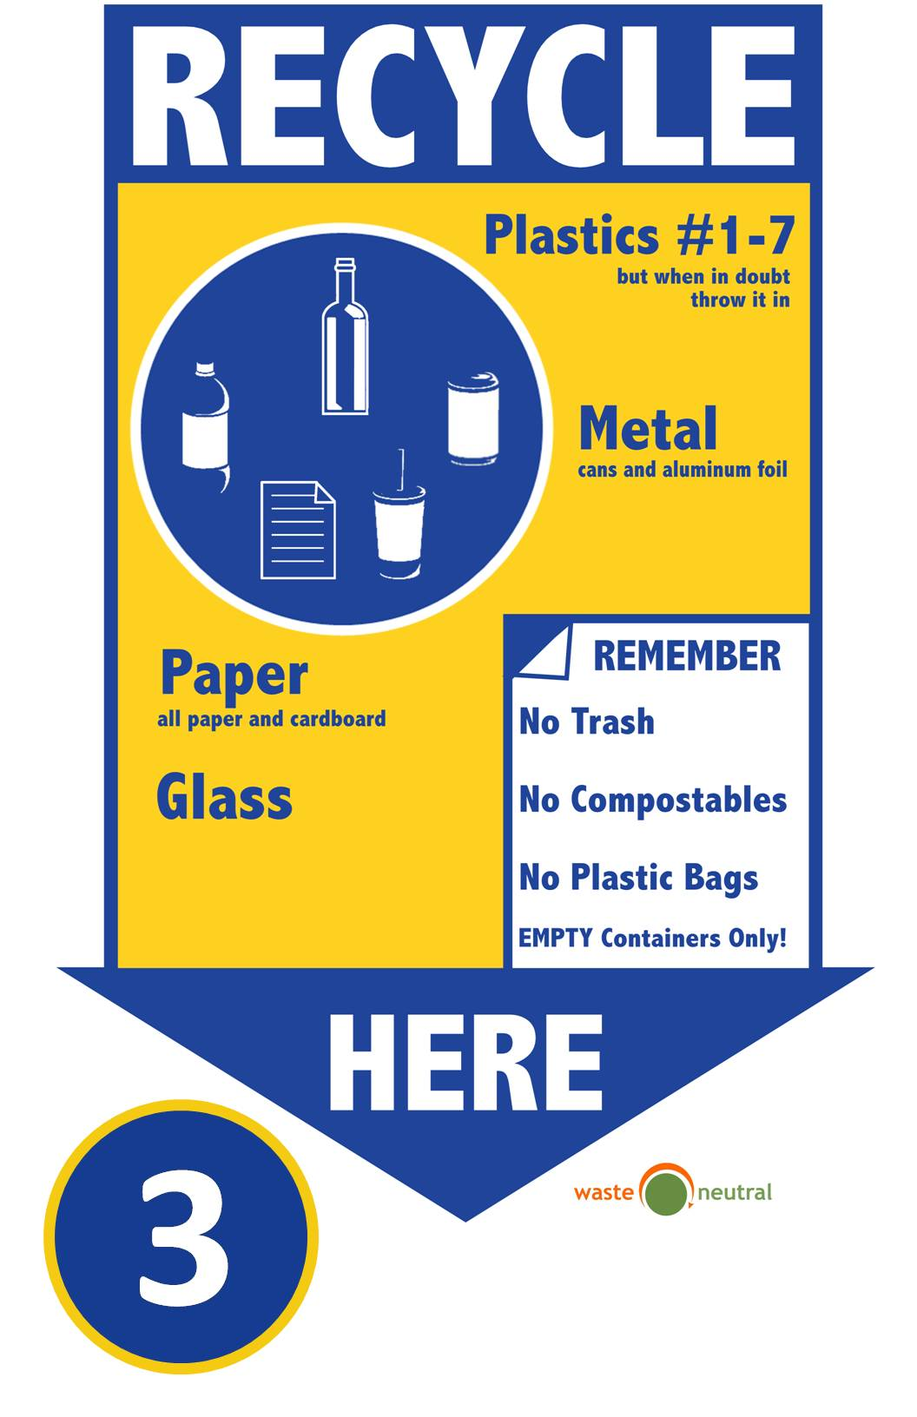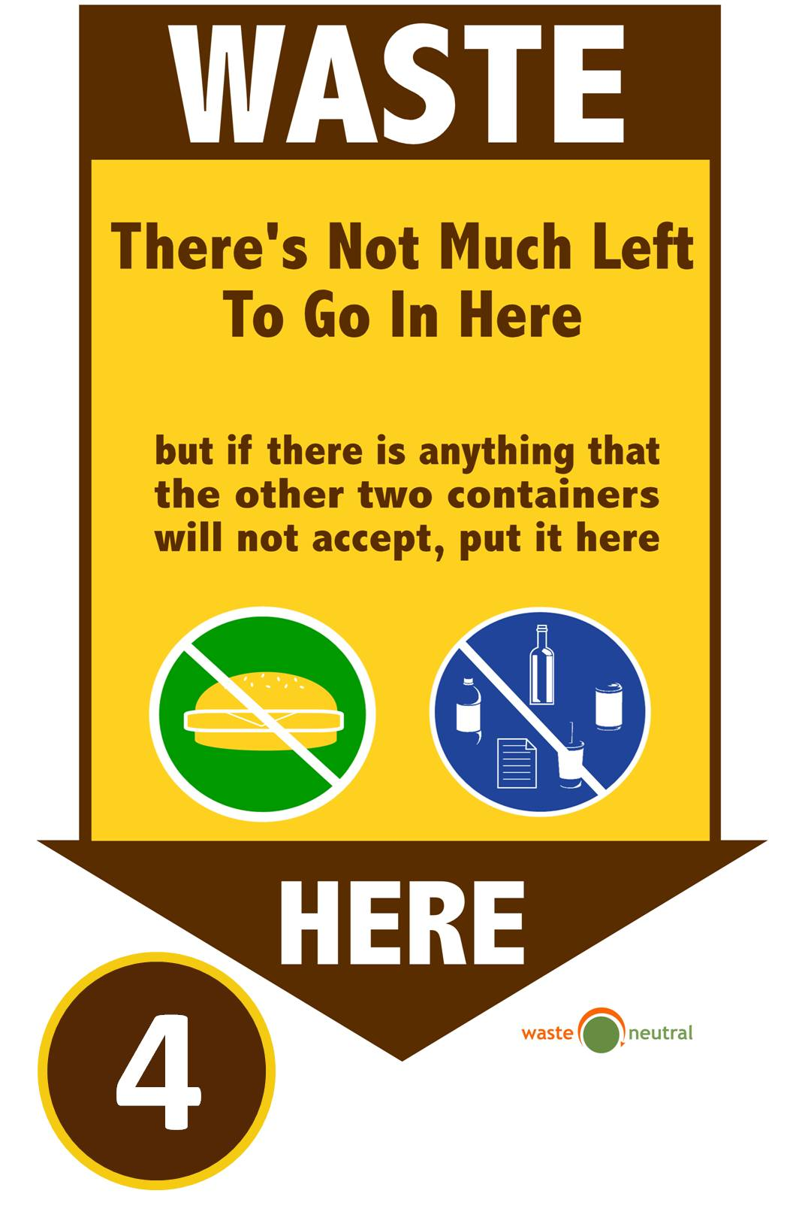

**Process (Collection and Composting)**

The containers would be collected by Waste Neutral, an organics hauler 2X or 3X per week depending on the volume. The food waste materials collected would be delivered to Peninsula Compost in Wilmington Delaware for processing. The compost facility would mix the food waste “feedstock” with the appropriate amount of carbon feedstock (leaves, chipped wood, cardboard) and convert these waste materials into compost. In the pictures below you will see how the compost facility piled the feedstock in the rows using a “windrow” method and covered them with a special Gore® fabric that accelerates the composting process.

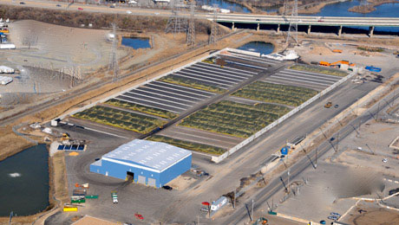 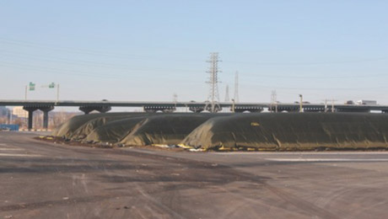

**Obstacles**

In the planning stage, from the team’s perspective, many schools dropped out between the contact stage to the organizing stage. It was a benefit to our project that we selected many schools to contact because there are many “at-risk” points throughout the year, from the beginning of the semester to just after winter break to spring break, where, based on our experience, schools are likely to drop out.

One of the biggest sources of frustration from school employees was the lunch tray and the individually packaged cutlery and napkin. Baltimore City Public Schools and private and charter schools use Styrofoam lunch trays to serve hot and cold foods to their students and many schools use the individual packs of silverware. Styrofoam is non-compostable and non-recyclable, and the trays size adds significant volume to the garbage bags from lunch. The plastics involved in the silverware are not compostable or recyclable. Many teachers and participants in the pilot expressed irritation with the trays and hoped to find a suitable alternative so as to further reduce non-compostable material.

After much research into alternatives, we concluded that there were no comparable compostable alternatives because of price. Styrofoam is extremely inexpensive. In lieu of the BCPS purchasing departments decision not to purchase the more expensive compostable product the school’s best hope was to identify alternative funding to purpose towards compostable lunch trays as two of our participants did. Another option is to move away from lunch trays at all and implement individual packaging per dish served. However this choice may too pose problems by increasing refuse. Further research and consideration must be taken regarding lunch trays in the composing system.

In addition to researching compostable alternatives, the team attempted to make the case that heated Styrofoam posed a health risk. Some plastics can leach Volatile Organic Compounds (VOCs) when heated or can lose microscopic particles of polymer when brushed with a rough surface like a fork, or in contact with hot liquids or foods. However research done for this project was inconclusive and the case of environmental harm due to Styrofoam trays could not be made.

Another issue that arose was resistance from janitorial and academic staff members. Some teachers and janitors were “nice but too set in their ways” (See Federal Hill, Amy Thomas) to really come around to supporting the project. Few participants surveyed mentioned student resistance, and no participants felt that resistance from teachers or janitors was insurmountable. These are important factors to consider and monitor when implementing a composting pilot project.

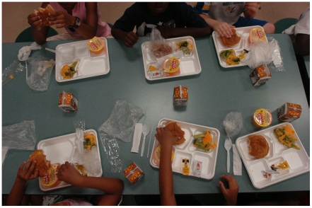

Current Styrofoam lunch treys

****

Example of compostable treys

**Results**

Our results are two-fold. First, each school drastically decreased their waste output for the dumpster, and filled many of the lidded, roller bins provided by Waste Neutral for composting. Those results are reported here. Second, individuals at each school completed a survey of the pilot and answered a range of questions from the volume of compostable material, to how students were engaged, to rodent sightings. Those results are represented in the survey answers.

**Volume of Compostable Material Diverted**

|  |  |  |  |  |  |  |  |  |
| --- | --- | --- | --- | --- | --- | --- | --- | --- |
|  | **BCPSS – F. Scott Key** | **BCPSS – Midtown** | **BCPSS – Montessori** | **BCPSS – Thomas Johnson** | **\* BCPSS – Calvin Rodwell** | **BCPSS – Living Classrooms** | **BCPSS – Curtis Bay ES** | **\*BCPSS – Federal Hill Prep.** |
| *Measured in pounds* | |  |  |  |  |  |  |  |
| **Nov 2011** | 0 | 0 | 140 | 191 | 789 | 0 | 92 | 1,885 |
| **Dec 2011** | 0 | 380 | 95 | 423 | 1,004 | 0 | 675 | 1,114 |
| **Jan 2012** | 0 | 986 | 259 | 0 | 1,400 | 0 | 310 | 1,582 |
| **Feb 2012** | 0 | 1,190 | 380 | 0 | 2,352 | 0 | 120 | 2,383 |
| **Mar 2012** | 0 | 716 | 205 | 0 | 2,350 | 0 | 265 | 2,555 |
| **Apr 2012** | 0 | 380 | 125 | 0 | 915 | 0 | 5 | 1,934 |
| **May 2012** | 0 | 1,075 | 522 | 0 | 1,617 | 0 | 0 | 4,111 |
|  |  |  |  |  |  |  |  |  |
| **Total lbs** | **0** | **4,727** | **1,726** | **614** | **10,427\*** | **0** | **1,467** | **15,564\*** |

\*NOTE: These two schools marked with an asterisk(\*) in the previous chart purchased compostable disposable trays with internal funding and experienced a sizeable increase in waste diversion

NOTE: Keep in mind these volume calculations are based on individual weight measures per container at the time of collection.

A few schools truly shined from support of students and staff, and exemplary implementation of the composting project. Here are those schools and their results:

**Federal Hill Preparatory** was, once compostable trays were introduced bins were consistently filling (overflowing in some cases). This school utilized five 48 gallon containers (each 48 gal toter is 0.238 cubic yards) at 2 pick-ups a week.  Therefore, we calculated that in a given month approximately ***10 cubic yards*** of organic waste was being diverted.

One huge step in the project we would like to highlight is the use of compostable trays. Below are the details of Federal Hill Preparatory.

**April** (before compostable trays were used):  1943 lbs diverted, or 9.7 lbs month/lunch served (200 lunches served daily), or 5.5 lbs per student/month (352 total students at school).

**May** (after compostable trays were used): 4111 lbs diverted, or 20.5 lbs month/lunch served, and 11.7 lbs per student/month.

**Net increase from compostable trays: 5.67 lbs per student/month**

This significant increase validates the recommendation of including trays into the diverted food waste program.  Based on what we saw, the increased weights are not only from the trays themselves, but from the food stuck to the trays that would otherwise not have been scrapped. Additionally, we noted a significant increase in student participation since the separation process became considerably easier to follow when the trays went into the compostable waste stream as well.

**Calvin Rodwell** regularly filled 2 1/2 48 gallon roller-bins at 3 pick-ups a week throughout the entire pilot period.  Based on the volume they filled, we can calculate that a total of 7.7 cubic yards/monthwere diverted in May 2012 and each of the prior months

**Midtown Academy** regularly filled 1 1/2 48 gal roller-bins at 2 pickups a week; they thus diverted at least 3 cubic yards/monththroughout the pilot.

**Post Pilot Feedback Questionnaire**

A comprehensive survey was sent out to each contact person at the conclusion of the pilot, encouraging any involved staff members to complete. Below are the results.

1. Have you visibly noticed reduction of volume of waste in the trash dumpster? Please rate on a scale of 1-5, 1 being no change and 5 being drastic decrease in volume of garbage dumpster since the introduction of the composting dumpster.
   1. Midtown: 5
   2. Fed Hill Prep part 1: 4
   3. Fed Hill Prep 2: 5
   4. Calvin Rodwell Elementary: 3
   5. Baltimore Montessori Public Charter: 3
   6. Curtis Bay Elementary Middle School: 3
2. Have you noticed a difference in student's attitudes about food waste? Please rate on a scale of 1-5, 1 being no change and 5 being a drastic change
   1. M: 4
   2. FHP1: 5
   3. FHP2: 3
   4. CRD: 3
   5. BMPC: 5
   6. CBEMS: 3
3. Please elaborate on your answer to the previous question. Do your students have a positive or negative reaction to composting? Are students engaged in the project? Are they bothered by the extra work?
   1. M: Positive
   2. FHP1: Both. Some students are excited while others see it as extra work.
   3. FHP2: For the most part, positive. Some kids are just defiant no matter what.
   4. CRD: Most students are engaged in the project. Once they learned the things that were able to be sorted out, they were engaged. There are still a percentage of students that do not pay attention to recycling the food waste and just throw their trays into the same bin.
   5. BMPC: Positive engagement. Students seem to understand the concept and carry the knowledge with them throughout the school.
   6. CBEMS: Nearly every student involved with our composting program has had a positive [sic] reaction. Students are more conscious of their [sic] disposed food and do their best to influence peers who have not yet adopted the same mindset.
4. Are students actively involved in the project? Please rate on a scale of 1-5, 1 being little active involvement and 5 being many students actively involved
   1. M: 4
   2. FHP1: 3
   3. FHP2: 4
   4. CRD: 4
   5. BMPC: 5
   6. CBEMS: 4
5. Are students gaining more environmental consciousness through the project? Please answer on a scale of 1-5, 1 being no students with a greater environmental consciousness and 5 being many students with a greater environmental consciousness
   1. M: 4
   2. FHP1: 4
   3. FHP2: 2
   4. CRD: 4
   5. BMPC: 5
   6. CBEMS: 4
6. Have you seen that the project has reduced the number of rodent sightings? Has the separation of food waste and the use of a liquid dump bucket aided in decreasing rodents? Please rate on a scale of 1-5, 1 being no change in rodents and 5 being reduction of rodents.
   1. M: 1
   2. FHP1: 4
   3. FHP2: not sure
   4. CRD: There was not a rodent issue before the start of the project.
   5. BMPC: Hard to tell
   6. CBEMS: Rodents were not visible before composting project.
7. Please rate the impact on the "smelliness" of your garbage dumpster since the introduction of the composting dumpster. Please rate on a scale of 1-5, 1 being no smell change and 5 being decrease in smelliness of regular garbage dumpster.
   1. M: 3
   2. FHP1: 4
   3. FHP2: 5
   4. CRD: 5
   5. BMPC: 5
   6. CBEMS: 3
8. Overall do you think composting of food waste is a positive thing for schools? Please rate on a scale from 1-5, 1 being not positive and 5 being very positive.
   1. M: 5
   2. FHP1: 5
   3. FHP2: 5
   4. CRD: 5
   5. BMPC: 5
   6. CBEMS: 4
9. What was the best thing about the project?
   1. M: Reduction of waste and increase in student environmental awareness and ability to "do something about it!"
   2. FHP1: Waste reduction
   3. FHP2: Watching the kids look at the 3 different bins and deciding, usually correctly, what goes where.
   4. CRD: The best thing about the project was seeing the students get excited about composting! Also, the positive impact it had on the environment.
   5. BMPC: Letting students educate each other on composting
   6. CBEMS: Students taking responsibility [sic] for their own actions and understanding that their food waste does not vanish once it is tossed into the dumpster.
10. What was the worst thing about the project?
    1. M: Nothing!
    2. FHP1: The small portion of kids that don’t care
    3. FHP2: The lack of support from the faculty and staff.
    4. CRD: Getting other staff members on board to help teach the students how to sort and recycle their food waste.
    5. BMPC: How long it took to get everyone on board and doing it in EVERY individual classroom, separately.
    6. CBEMS: Challenges involving custodial and cafeteria staff and implementing [sic] the program on multiple lunch shift without adequate support
11. What would you change about the project?
    1. M: more ongoing education about the benefits of composting and connecting the students with a garden project that is receiving our soil.
    2. FHP1: Add compostable trays and bulk Spork, straw and napkin. Not the individual wrapping.
    3. FHP2: Involve the cafeteria and janitors from the beginning; make taking out the compost and recycling bins part of their job description.
    4. CRD: I would change the project to not only include the lunch room, but expand it to the classrooms and staff lounge.
    5. BMPC: Centralized location for bins. Someone to own and manage the bins besides me.
    6. CBEMS: I would strive to make the project mandatory and requiring custodial staff to be a supporting force not a hindrance [sic].
12. What factors helped the most in implementing composting at your school?
    1. M: Staff input and Patrick’s (waste neutral) incredible commitment and support
    2. FHP1: The parent, teacher and student involvement.
    3. FHP2: The parent volunteers and Waste Neutral.
    4. CRD: The student’s excitement for doing it and a particular staff member was able to assist in the cafeteria and help direct the students on how to sort correctly.
    5. BMPC: Administrators on board, student and teachers followed.
    6. CBEMS: Enthusiastic students, forgone lunch breaks, Established green team within school
13. What was the biggest barrier to the project?
    1. M: None
    2. FHP1: Changing student and staff attitudes about food waste.
    3. FHP2: The faculty and staff, and ketchup packets
    4. CRD: Other faculty and staff support
    5. BMPC: The fact that we have no centralized cafeteria.
    6. CBEMS: Custodial/Cafeteria Staff who believed composting was adding more work to current duties.
14. Is there anything else you would like to add?
    1. M: Please have all schools in the city compost!
    2. FHP1: I think composting in the schools is an important and necessary step toward the future of our sustainability.
    3. FHP2: N/A
    4. CRD: I believe this was a great pilot program for our school to be a part of. I am looking forward to continuing the food waste recycling program. It not only benefits the environment, but hopefully teaches environmentally friendly habits that the students will take with them.
    5. BMPC: N/A
    6. CBEMS: I would like to continue the program if possible but composting, like recycling must be made a city wide requirement for all schools.

Overall, we were very satisfied with the results of the pilot. Schools ended the year feeling positive about composting and looking forward to continuing in the future. Funding, resources, and support will pose an issue to continue the project, but school participation and success will not.

**Notable Quotes/ Feedback from Participants**

**Federal Hill Preparatory- Parent Volunteer Amy Thomas**

“Composted went super well, main complaint is about the staff- they’re nice but they’re set in their ways. The kids love it- in their routine. They’re committed to sticking with it.”

“Beginning was wonderful but they’ve all kind of dropped off. Older kids are becoming disinterested as the ages go on”

**Calvin Rodwell Elementary- Teacher Krystle Tennyson**

“It’s great for the kids to start thinking about what happens with trash, i.e. that it doesn’t have to go the landfill”

“It was just more getting an efficient strategy/ routine in the lunch shift. Make it mechanical. The older kids have really taken a good role in leadership. The first and second graders have really had a harder time but are getting on board “

**Baltimore Montessori Public Charter School- Chef Patrick Caulfield**

“It’s been a really rough growing pain- I had to make it a mission. A lot of other places have a cafeteria and that would probably be easier than us. “

“People are very uncomfortable with things that are alive and can die- decompose. It’s even the idea that things can be temporary which goes against permanent things. Kids get really uncomfortable about it but as soon as they are educated they seem to be ok with it”

“It’s really polarizing- some kids see it as awesome but some kids see it as not cool at all. It’s mainly like the older they become the less cool it become. The little ones love it and are into it. We used the model as having the kids educate the classrooms and that worked really well.”

**Commentary and Reflection**

One of the things that I would caution others against is trying to justify a systematic composting initiative based on cost avoidance as the main motivator. Although it is true that there is cost avoidance associated with the project by reducing your solid waste collections, this should not be considered a cost savings initiative. Also, you want to get a multi-sector team of stakeholders involved right from the get-go, and keep them involved all the way through implementation.

There are additional costs associated with the collection of organics and the move to compostable disposable products, and it’s also fairly challenging from an administrative perspective to coordinate. So it has to be a labor of love, in the end. And it has to be understood as something the school system is pursuing because it is the right thing to do.

Overall, we feel this project was a success. We initially had many schools involved in our pilot and while some dropped out; we still were very satisfied with the amount of schools that participated.

In the five schools that successfully implemented a lasting composting project, most of which were able to reduce their dumpster volume by almost 50%; students were engaged via curriculum, practice and theory, and teachers were behind the project. Many reports indicated that for students the process became second nature, which was the ultimate goal.

There were challenges in the form of materials cafeterias used, resistant teachers or janitorial staff, and the unique challenges of specific school layouts. We anticipate that there will be additional challenges as new students enter the school and if the original contact(s) leave with no succession plan is in place. Additionally, we feel the composting program district wide could be greatly strengthened by an administrator monitoring progress from within the school system. However; the drive, practice and understanding of the benefits and challenges of composting were instilled into students and teachers alike, which is the most valuable and immeasurable success to the pilot.

**Engagement and Support**

The Baltimore Office of Sustainability coordinated the composting project from the start with the buy-in from the BCPS administration. They sourced and selected the organics waste hauler and administered the funding through the Baltimore Community Foundation. A team coordinated by an intern from Johns Hopkins was put together from these strategic partners to work closely with the individual schools.

**Funding and Resources**

The total costs associated with this project were approximately $25,000. The majority of the funding was provided by the U.S. Environmental Protection Agency “Resource Conservation Challenge Grants.” The balance of the start-up costs came from Constellation Energy and the Baltimore Community Foundation mini grant program.

**Contact Information**

Abby Cocke, Baltimore Office of Sustainability Coordinator

410-396-1670

Abby.Cocke@baltimorecity.gov

<http://www.baltimoresustainability.org/>

Case study submitted by:

Zoe Kaiser, Student Johns Hopkins University

Anticipated Graduation: Fall 2012

**Exhibit A**

**I. Handout 1- Composting Pilot “HOW TO” Sheet.**

**HOW TO DIVERT FOOD WASTE AT YOUR SCHOOL**

MATERIALS NEEDED:

* 1 or 2 trash bins
* 1 or 2 recycling bins (if school currently recycles)
* 1 or 2 food waste (composting) bins
* 1-2 small liquid buckets placed on top of a tray cart or small table
* Trash bag liners ready at hand. Ideally, use one specific color for each waste type, reserving clear bags for food waste.
* Gloves

VOLUNTEERS NEEDED:

* 2 student volunteers during lunchtime
* 1 teacher / faculty coordinator. Required to be present for first 2 weeks, thereafter optional based on success of program.

COLLECTION OF FOOD WASTE: *A sequential order of what to do*

1. Prior lunch session, check to make sure all materials (see list above) are at hand
2. Coordinate with custodian where filled bags emptied into dumpsters. Replace bags at ¼ full!
3. Select an easily accessible location to set-up the separation station. An area near the tray return is ideal. Your chosen location should encourage only a single line of approach for students and allow for only one path for exit.
4. Line-up bins in following order from the student's approach: (Be consistent - do not shuffle the established order)
   * 1st - liquid bucket(s) on small table or cart
   * 2nd - Food waste bin
   * 3rd - Recycling bin (if school currently recycles)
   * 4th - Trash
5. Student should be instructed to ALWAYS dispose of their waste in the PROPER NUMERICAL ORDER of the signs that were provided to you (see example below). They must first empty liquids into liquid bucket and go from 1st to 4th waste type.

HELPFUL RECOMMENDATIONS

* The labeling of bins and posters helps. However, the use of colors, shapes and a numerical order of disposal are more effective in establishing the desired muscle memory in students. Students will quickly associate a specific color with a waste type. For example: green or brown bin = food waste, blue or yellow = Recyclables, and grey or black bin = Trash. If all bins are the same, try to associate colored bag liners with a specific waste type.
* If the school allows, it helps to pin or tape product examples to bins or posters during the start of program, especially on items a student might not be sure about.

**Exhibit A Cont.**

* Keeping the numerical order of disposal the same is THE easiest way for students to remember.
* Students tend to finish with their food at the same time and may “rush” the separation station. It is critical that you enforce the disposal of waste in the specific numerical order on the FIRST day and strictly enforce it (- it will become hard to enforce on 2nd day once bad habits are formed). The presence of a teacher is therefore needed for initial days! If students are allowed to approach from multiple directions and go out of order, the process WILL slow down, become clogged, and breakdown.
* It is best to line-up bins in straight line parallel a wall. Allow a small distance from wall for the volunteers to stand behind the bins facing students. After two weeks, or once the process runs with minimal supervision, the separation station can be moved against the wall.
* Coordinate with custodian on how to empty bins and where bags are taken.
* By separating food waste from your regular trash dumpsters and placing it into the green roller bins that were provided to your school for collection, we can help reduce current odors and accessibility by rodents. Be sure to tie a knot around the neck of each bag (instead of tying corners) before placing a food waste bag into the provided green roller bins. This prevents leakage and keeps all odors locked inside the bag. Always keep roll bin lids closed.
* Reduce the possibility of a spill by not overfilling bags. A bag should be tied-off and removed from a bin when it before it reaches ½ full. Food waste is very dense and heavy. The more frequently you tie-off and replace bags, the easier they become to handle.
* Make sure all students drain beverage containers into liquid bucket, it will make both recyclable and food waste bins less wet and much easier to handle for student volunteers.